Assignment 4 | 1905074

How to run Code:
PCA: python -u "path to parent folder \1905074\codes\1905074_PCA.py"
EM: python -u " path to parent folder \1905074\1905074_EM.py"
Note: keep the input files in the codes folder

PCA Plots:
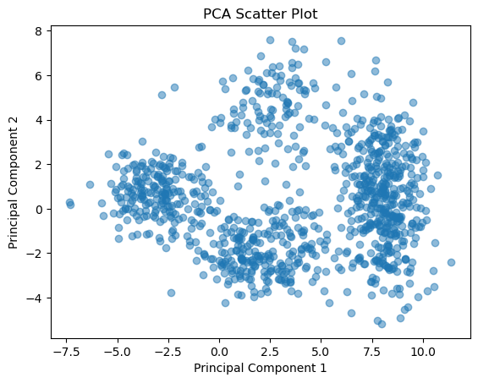
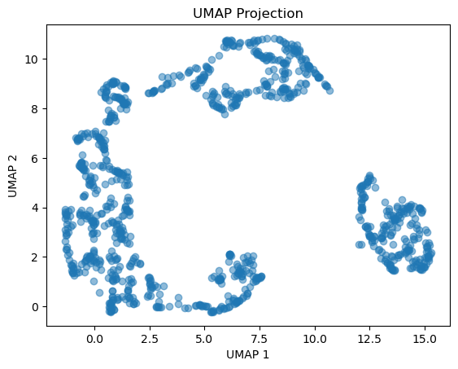
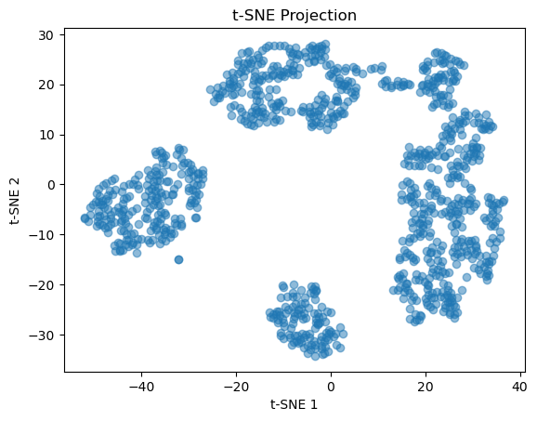

EM Algorithm result:
Mean number of children in families with family planning: 1.7889842647985699
Mean number of children in families without family planning: 4.916301802525844
Proportion of families with family planning: 0.35791114558174286
Proportion of families without family planning: 0.6420888544182571

